How to install the Barcode Font:

Follow the steps for your Operating system.

Windows XP or Windows NT
Windows Vista or Windows 7

Windows XP or Windows NT

- Go to http://ccsginc.com/vendornet_documentation.htm
- Right-Click on “Bar Code Font” and do a save as. For Windows XP save to c:\windows\temp for Windows NT save to c:\winnt\temp
- Once the file is saved, type the following into the address bar... for windows XP users type in C:\windows\fonts or for Windows NT type in C:\winnt\fonts this will take you directly into you fonts folder.
- Click on “File” then “Install New Font”
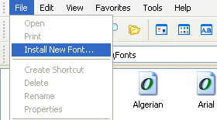

6. This will open a box that looks like this.

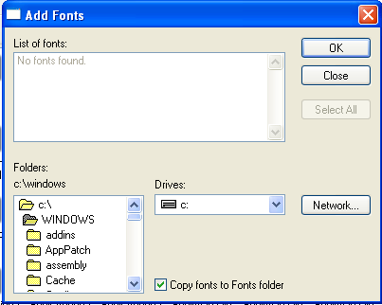

- From here go to the Folders list in the lower left and go to your Temp folder. When you open it you will get a font in the “List of Fonts” at the top of the window and it will look like this.

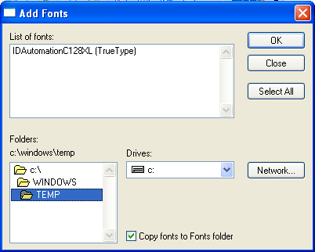

- Click on the “IDAutomationC128XL (True Type)” and click ok. This will install your font.
- You’re done. If you have any further problems let us know.

Windows Vista or Windows 7

- Go to http://ccsginc.com/vendornet_documentation.htm
- Right-Click on “Bar Code Font” and do a save as. Save to your desktop.
- Go to your desktop and Right-Click on the “Bar Code Font” titled “IDAutomationC128XL” or “IDAu000” Click on “Install”

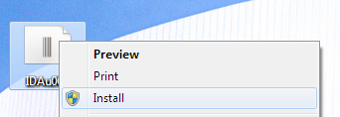

- You’re done. If you have any further problems let us know.

If you need further assistance please contact:

Vendor Technologies Group
VTG@cornerstonebrands.com

